**INTRODUCTION TO AWS IAM**

Pham Huu Hung – 102643407

Accessing AWS management console and select IAM from menu.

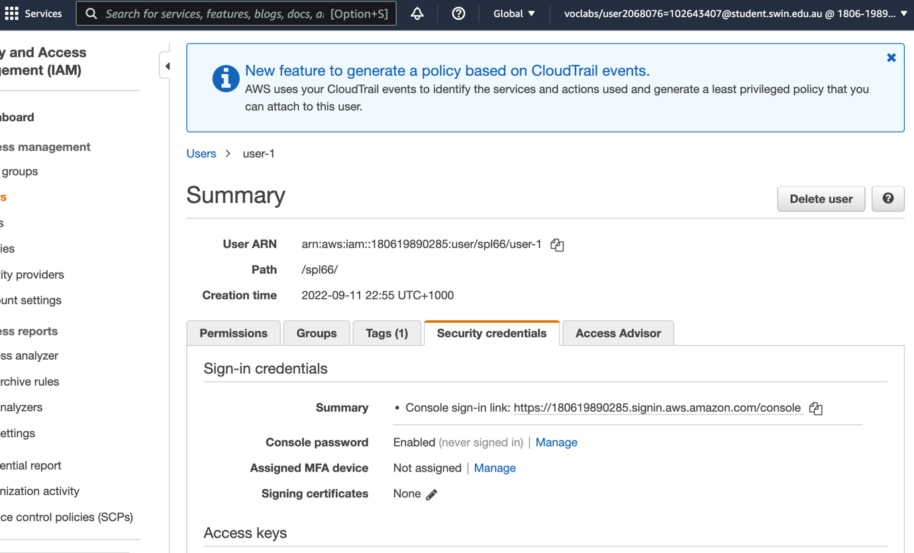

This shows user-1 is assigned to a console password

Choosing the permission tab from EC2-support group

Checking the policy of the user group EC2 support

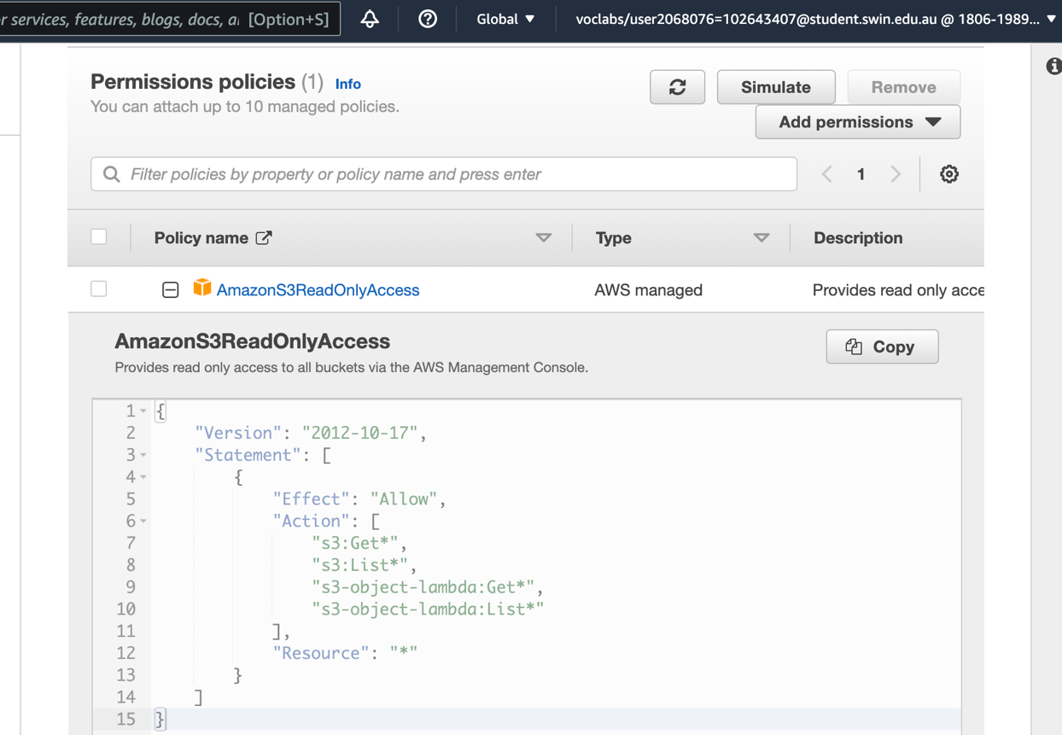

Checking permission to Get and List resources in Amazon S3

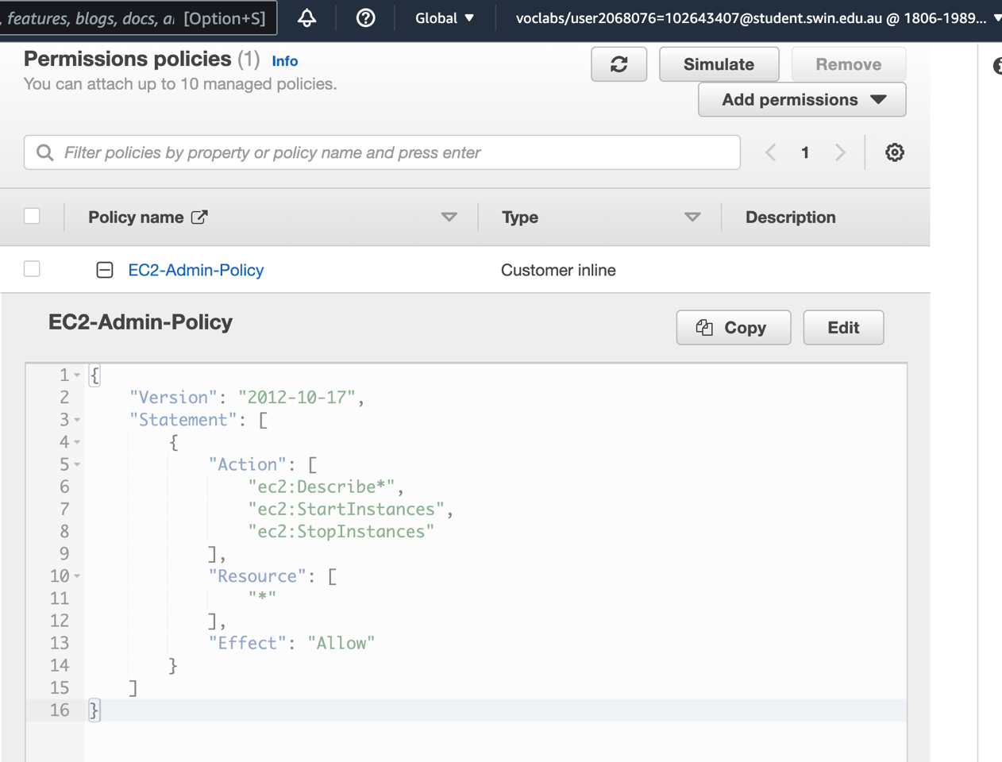

Checking policy of EC2-Admin

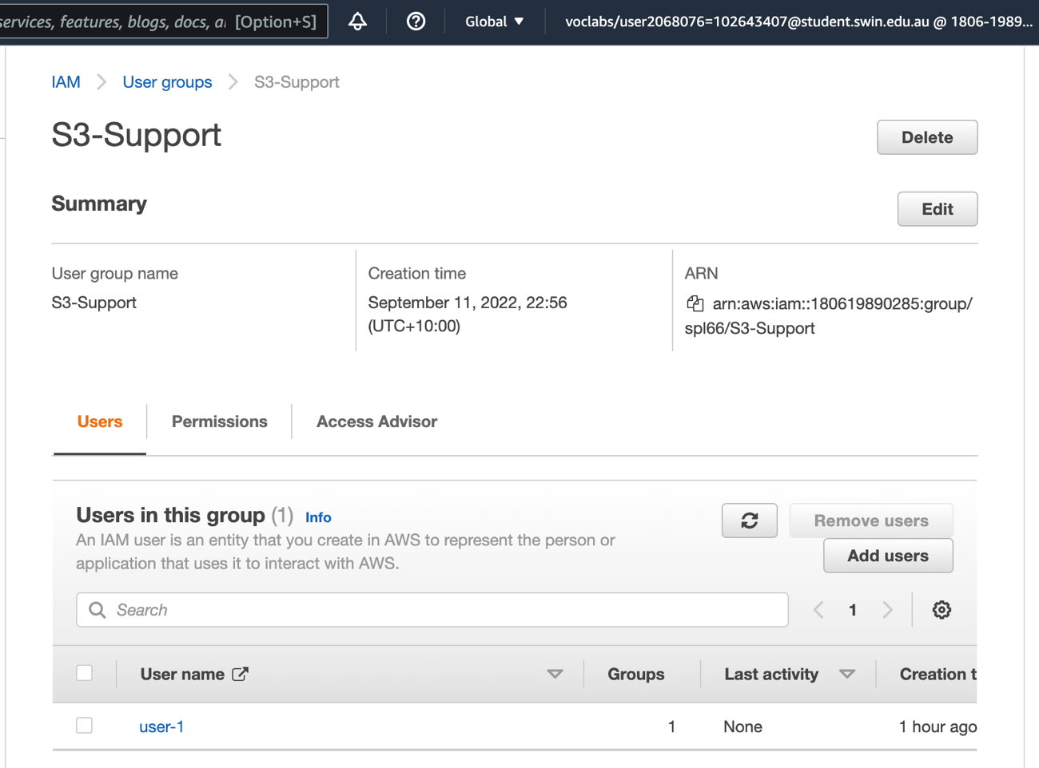

Add user 1 to S3 user group

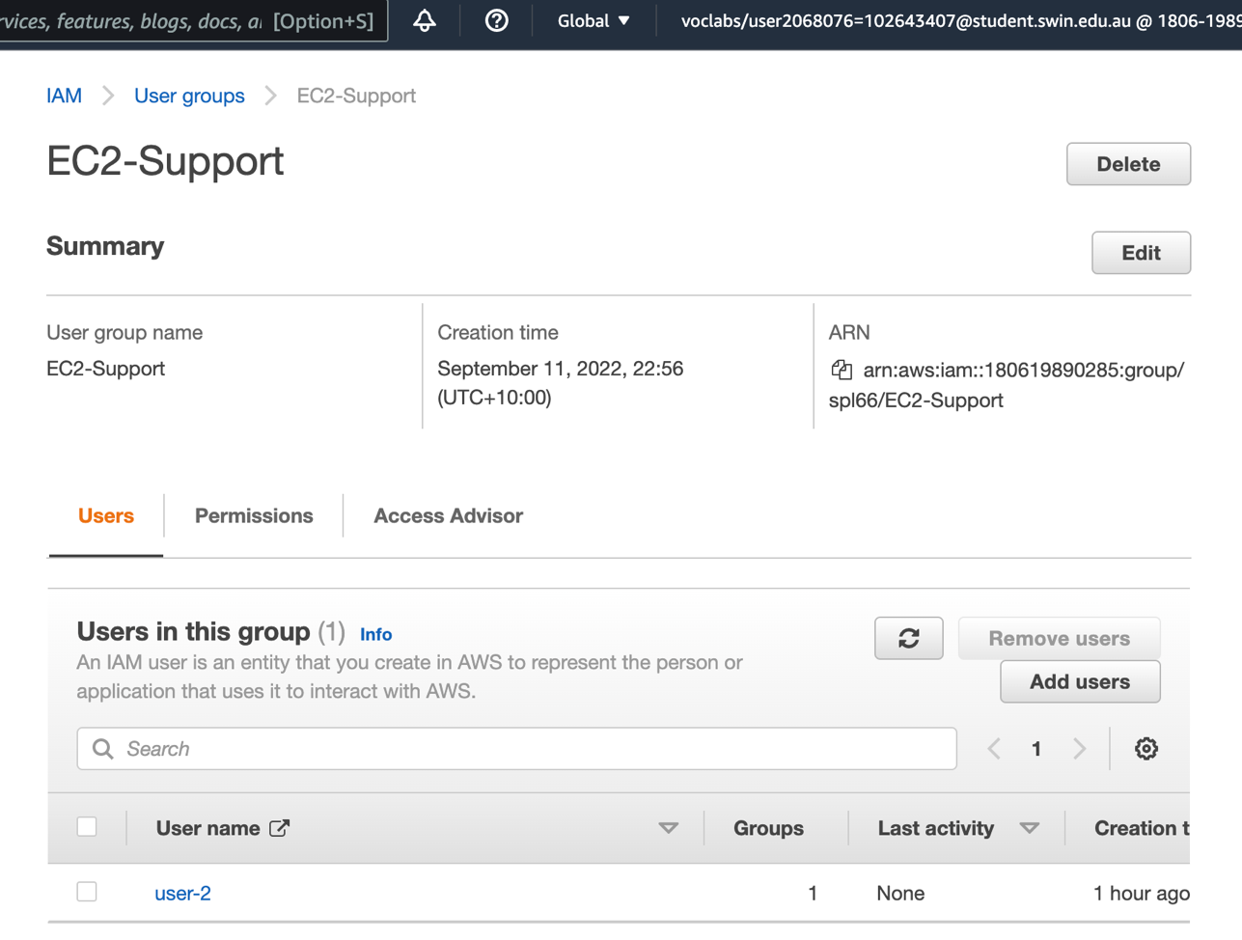

Add user 2 to EC2-Support

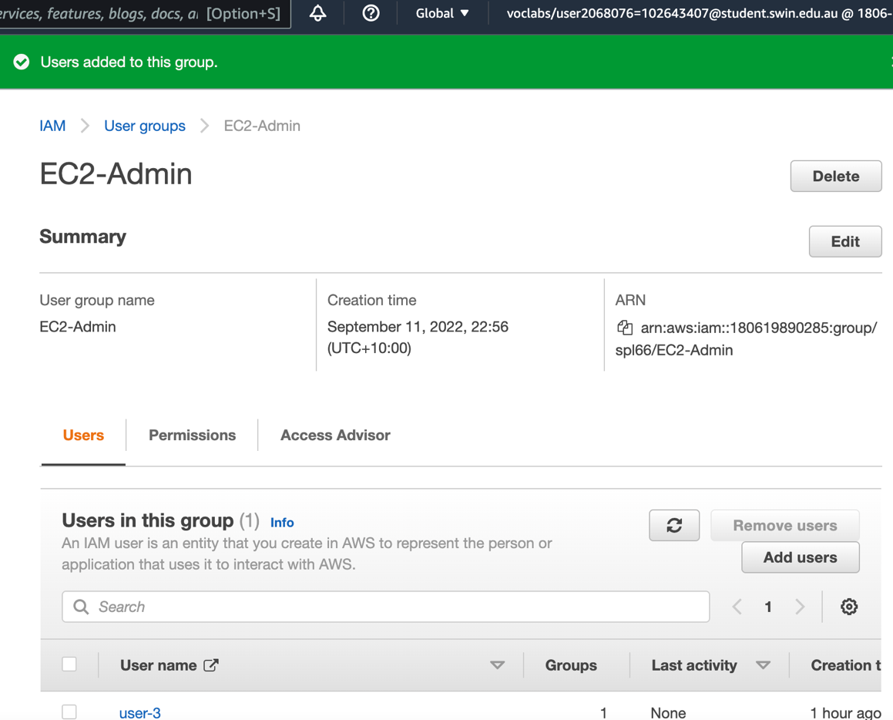

Add user 3 to EC2-Admin

Sign in with user 1 using incognito mode

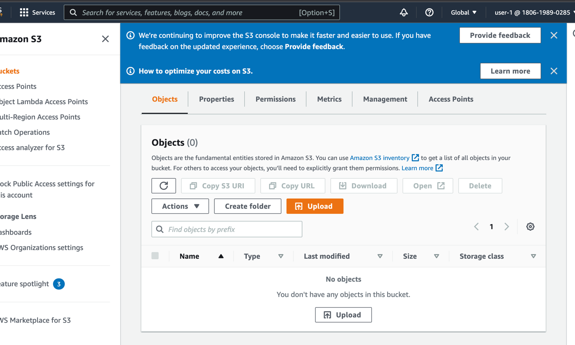

Check the permission to view list of S3 bucket

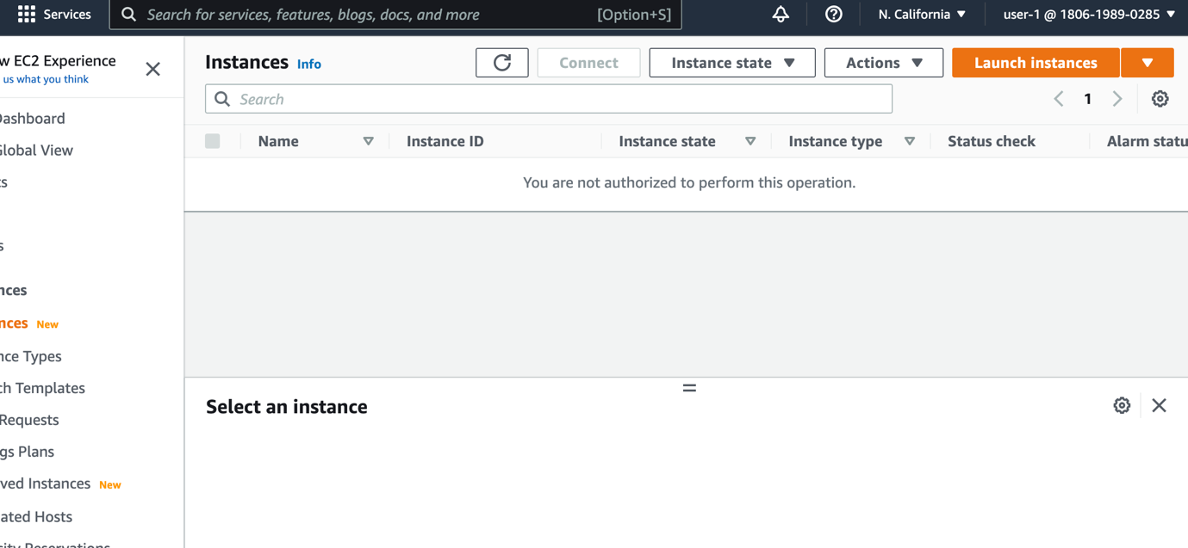

User 1 does not have access to amazon EC2, we need to sign in user 2.

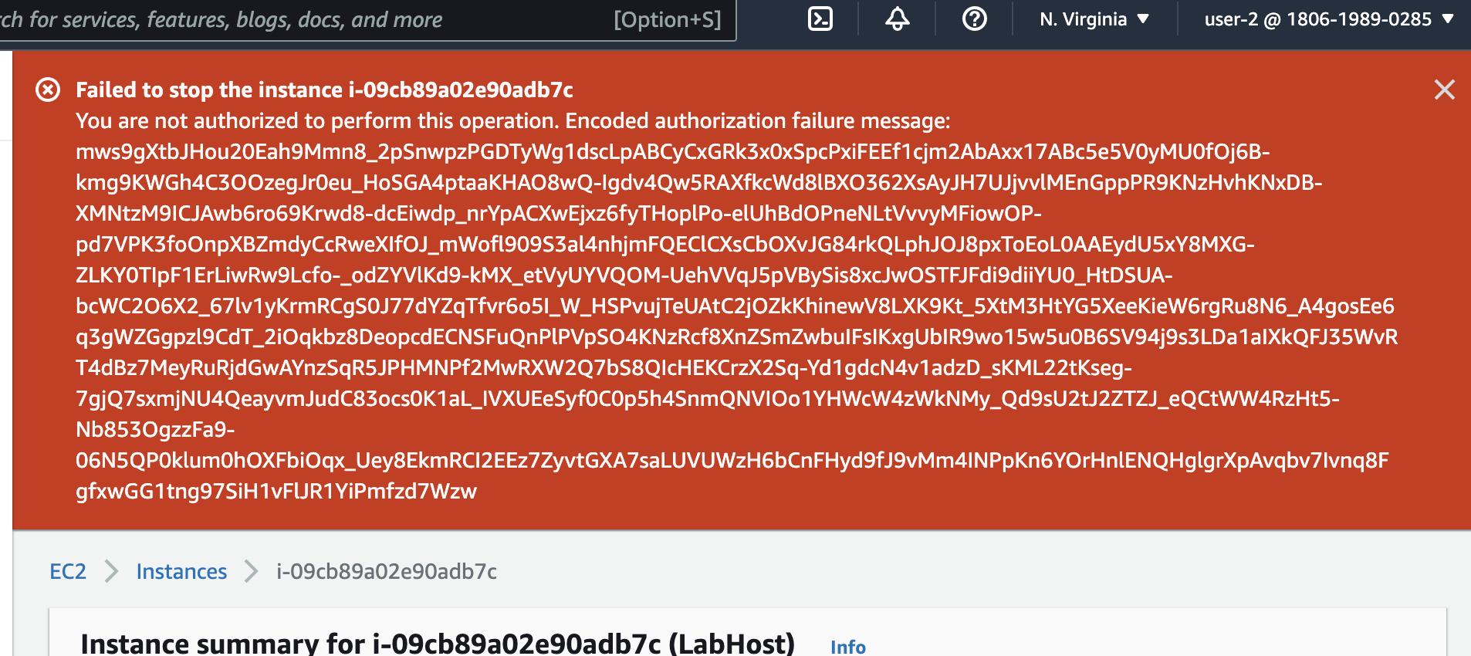

Checking if user 2 is assigned the authority to read only, not making any changes.

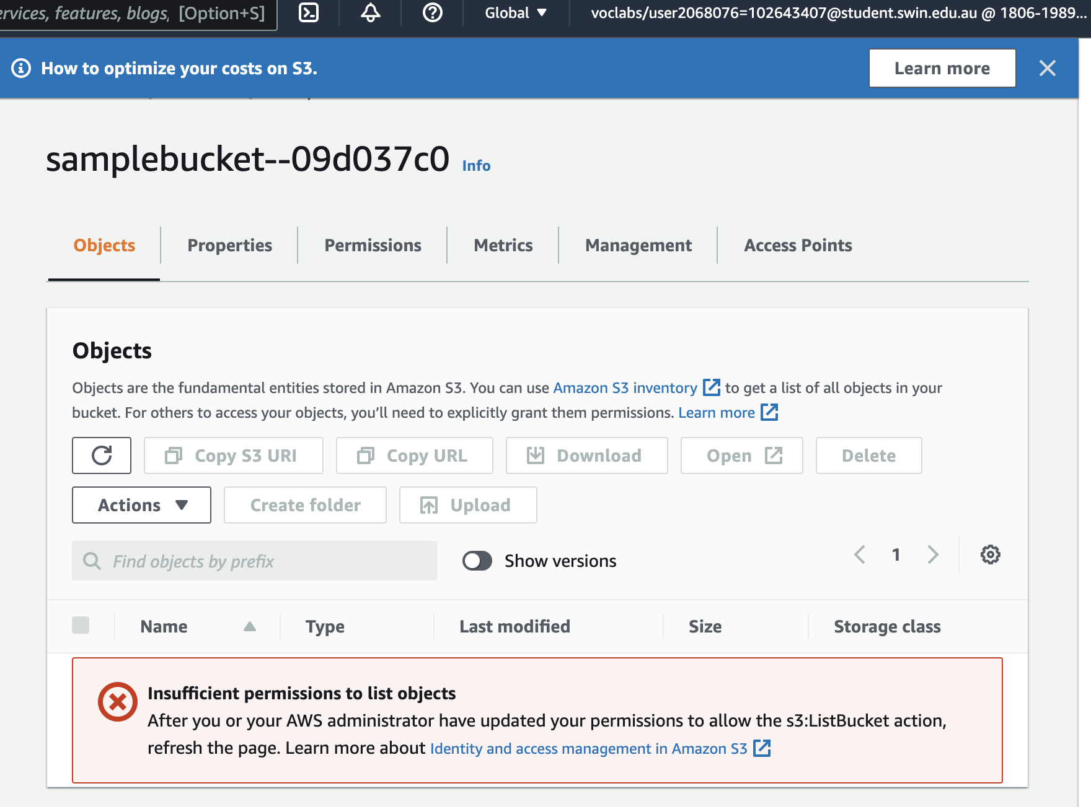

User 2 does not have authority to S3 bucket

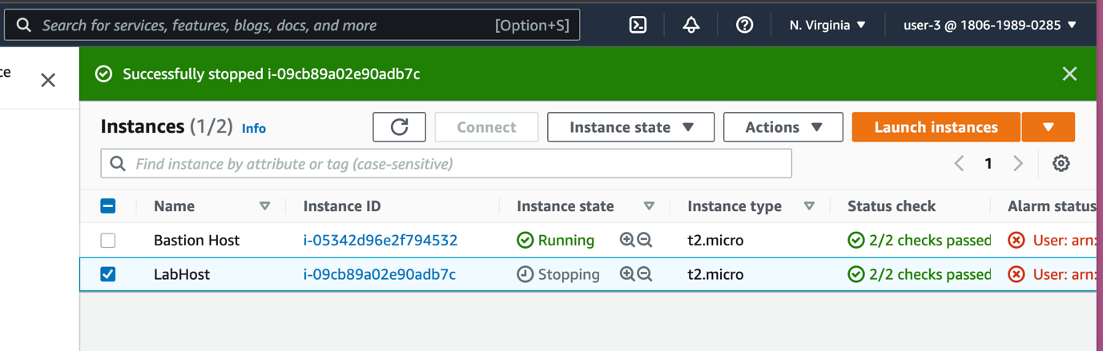

Stop instance with user 3

Lab completed